Software Requirement Specification for

Project: What to Take

Prepared by: Sam Yan

Wenzhou-Kean University

21st February 2017

1. Introduction

This project is a decision-making system which helps users to build up their diets based on their health profiles. Using the spiral model, 3 versions of applications will be developed and the final outcome of this project will be the version 3.0 of “What to Take”. This document refers to the standard IEEE Software requirements specification template and the convention of assignment-submission works of Wenzhou-Kean University. The font is *Times New Roman*, of size 10.5.

This document of Software Specification is written for any potential users of this software, namely, nutritionists, athletes, physicians and any other application users who are interested in the topic food and healthy living. Particularly, this application will follow the user requirements specified by professors from biology department of Wenzhou-Kean University, who will act as the user group during the designing and developing phase of this application.

Apart from general users who are interested in self-specified decision making of dietary planning, this application also considers the user requirements for nutrition experts and cooperation vendors of food and drinks. It is a platform for cooperation vendors to sell their food and experts to give their opinions to general users and earn benefits by offering those advice to general users.

By finishing the requirement specification, this project is supposed to finish following tasks:

1. Gather and document users’ requirements, especially the explicit and implicit requirements that they are not able to be satisfied with from general applications of similar themes.
2. Finish the design work of phase 1 of the whole develop procedures and hopefully 20% of the work of phase 1 can be finished.
3. Half of the design work should be finished, the whole document of designing specification shall be submitted for approving one week after the official approving of this document.

The purpose of this application is to support users to generate their own plans of diets using the novel new algorithm specified in the approved proposal, with its core contribution of providing user-specific plans. Users shall be able to improve living qualities and improving health conditions from this application by following the plans made according to their health profiles that are made specifically for them.

Using this application, vendors from specific food or drink industries could have chances to advertise their products, serving as a potential business model. The payment amount of advertising products shall consider the original value of the product and the amount of users paying attention to the advertisement.

The whole document and the later documents and procedures shall follow the plans and schedules specified previously in the approved proposal.

1. Description

2.1 Perspective

This application tends to be an improving version of current applications under the theme “health living”. As stated in the project proposal, current applications of this theme tends to record users’ diets or exercising behaviors only. Based on traditional usages of those applications, this application not only records data, but analyze data in order to fulfill the requirements of individual users according to nutrition theories and certain novel new algorithms specified by this project in the proposal part.

2.2 Functions

The functions are specified in section 4.4 of proposal already, apart from those, the application needs to add a function which is being able to let food vendors advertise their food, considering the requirements of the business model. The overall functions might be slightly modified in the final, but the modifications shall not affect the overall functionality of the original designed functions provided by this application.

2.3 User classes and characteristics

Users of this application are general users who have potential interests about healthy diet. However, considering the scope and the specialty of this applications, users are grouped into three roles as specified in the previous proposal, namely, customers, registered users and expert users. A special class till this moment this application has to add is the cooperation users and this is one of the most important roles in this application.

The characters of customers (visitors) are those who just want to have a general look about the application and who are not interested in specific dietary plans, thus those users are not that important compared to those who are able to register and are interested in user-specific dietary plans, expert users and cooperation users.

The registered users are those who are interested in specific healthy diet planning and are one of the most important roles of this application. The vast number of users serve as the potential buyers from cooperation vendors and customers of expert users.

The experts are users who have fully accesses towards the information about food and planning algorithms of users. They might benefit from providing more specific plans for individual users and are awarded if their plans are better than the automatic generated plans by the algorithm from this project.

The cooperation vendors should be able to advertise their products and shall be charged if their visitors reach a certain amount. They should also be satisfied because the vendors are the key of the business model of this application.

2.4 Initial Platform

The application is designed to be a desktop one on Windows system at its first phase and it shall be able to run on Windows 7 or later versions. To run this application, the internet connection is required.

2.5 Constraints

The development of this application has following constrains:

1. Time limitation: The application shall be reached to its first phase near around 5th March, its 2nd phase around 2nd April, so time limitation might be a constraint for this application.
2. In order to satisfy a real server-client model, a real server with abilities of holding huge amount of data is required, but it becomes a constraint since no server is available on this campus.
3. Due to private protection policies, the access towards users’ health profile and user registration information should be managed.
4. This application does not consider parallel access towards database, thus two users are modifying the same table at the same time, a problem might occur. The whole application is based on single thread at first two developing stages.

2.6 Assumptions and Dependencies

This application shall include some paying systems, thus may using API systems such as Ali API to get the information of whether users paid or not.

1. Interface Requirements

* 3.1 User Interfaces

This application mainly communicates with users through graphic user interfaces (known as “GUIs”). In order to satisfy the proposal and user requirements, following GUIs (but not limited to) shall be provided:

1. A GUI for user access control (log in panel). Based on user identities, this panel shall be able to guide users to their corresponding interface groups.
2. A “help” GUI (also introductory GUI). It provides introduction about this application and at the meanwhile serves as the interface for customer users.
3. A GUI which reflects registered users’ personal information.
4. A GUI which gathers and reflects registered users’ health information.
5. A GUI which gathers and reflects registered users’ diet information.
6. A GUI which provides registered users with their health evaluation and future suggestions (suggested food by certain experts and cooperation).
7. A GUI which provides connections between users and experts.
8. A GUI for expert users to check users that are connecting him or her.
9. A GUI for food vendors to post their food and pay their advertising fees.

* 3.2 Software Interfaces

In order for this application to run, following software interfaces shall be required:

1. MySQL 5.7
2. Windows 7 or above versions

* 3.3 Hardware Interfaces

This application does not have specific constrains about hardware interfaces. Any computing devices that runs operating system Windows 7 or above shall be fine.

* 3.4 Communication Interfaces

This applications require communication between the application and the database system, thus the connection between the application and the database is needed. During the implementation and testing phase, the local server (IP: 127.0.0.1 is used).

If time allowed, the application shall be made into real server-client mode, thus network sockets shall serve as communication interface in this case.

1. Use Cases

* 4.1 Actor list
  + Customers: Any person who is interested in getting general ideas about healthy diet.
  + Registered users: Any person who is interested in getting specific plans about healthy diet based on the person’s individual conditions.
  + Experts: Qualified nutritionists who are able to give registered users specific dietary advice based on their health conditions.
  + Vendors: Those vendors of food and drink who would like to advertise their products.
* 4.2 Use case list

1. Customers can input BMI.
2. Customers can get advice according to his or her BMI.
3. Customers can register if they are interested in this application.
4. Registered users should be able to input and modify his or her health conditions and those information will be stored in “health profile”.
5. Registered users should be able to log in and log off.
6. Registered users can watch his or her health profile.
7. Registered users can get results about his or her health evaluation based on information he or she input to the system for free.
8. Registered users can ask help from expert users by paying consulting fees.
9. Registered users can check up the remaining of his consulting fees and add more if he or she wants to.
10. Registered users can record his or her exercises being performed.
11. Registered users can record or modify his or her diets.
12. Registered users can add information about food / drink, and if the information got qualified, he / she will get credits.
13. Expert users can modify the automatic generated diet plans for users and get payments.
14. Expert users can modify or verify the information about food / drink.
15. Expert users can log in and log off.
16. Cooperation vendors can log in and log off.
17. Cooperation vendors can add food/drink information they would like to sell.
18. Cooperation vendors can choose whether or not to advertise their food / drink.
19. Cooperation vendors can check his or her remaining fees.

* 4.3 Use case diagram

Below shows the use case diagram of this project.

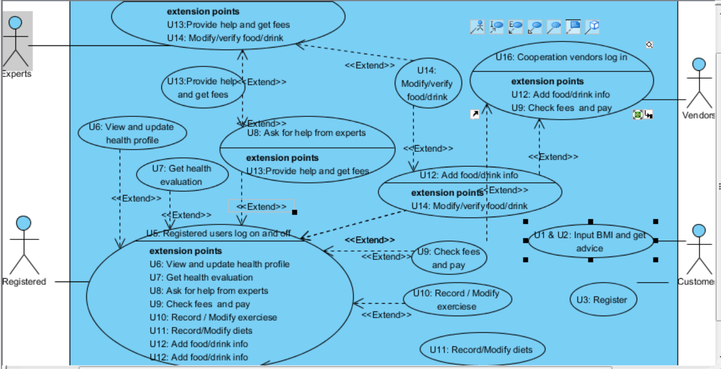

* 4.4 Use case details
* U1 and U2: Customers can input BMI and can get advice according to his or her BMI:

Customer users can input his weight and height, the system calculates the user’s BMI and return the general information about nutrition in-taking.

* U3: Customers can register if they are interested in this application.

Customers can register if they are interested in this project and thus becomes registered user.

* U4: Registered users should be able to input and modify his or her health conditions and those information will be stored in “health profile”:

Registered users should be able to access to a frame called health profile and there they are able to modify their information about their health conditions.

* + U7: Registered users can get results about his or her health evaluation based on information he or she input to the system for free:

The system will automatically generate menu based on the input of the users for free. However, if the users are not satisfied with the results, they might contact experts to get better advice, in this case, the users have to pay for the experts.

* U10: Registered users can record his or her exercises being performed:

There should be a frame for users to input his or her exercise items and duration, the system should be able to calculate the calorie consumption and return the value to the users.

* + U11: Registered users can record or modify his or her diets:

There should be a page for user to record and modify his menu item by item, including: item name and item amount, the system should calculate the calorie and check the food safety issues of input item (whether they are “conflict” as specified in proposal).

* + U12: Registered users can add information about food / drink, and if the information got qualified, he / she will get credits:

If there exist food or drink that the system is not included, the users are allowed to input and will get credits (can be used to exchange money for getting help from experts). If there information about such food is verified by experts, they can get more credits.

* + U13: Expert users can modify the automatic generated diet plans for users and get payments:

If users ask for help, the experts can check whether the diet generated by system is suitable for him or her. If the result is suitable, the system does rollback the money paid by the users. However, if experts recommend a better diet, the system gives 90% of the money to experts and remains 10% for itself.

* + U18: Cooperation vendors can choose whether or not to advertise their food / drink:

If cooperation vendors choose to advertise their food/drink, the brand of the food / drink will be attached with the vendors so that their food/drink will be advertised and users are able to click on those to quickly check information. Otherwise, the system does not advertise their food/drink and their food/drink will simply be stored in the database. The system will charge the vendors based on the amount of users clicking the link of their advertisements.

1. Nonfunctional Requirements

Apart from functional requirements that are specified in this document and the previous proposal, there are some non-functional requirements of this application, including but not limited to:

1. This application shall be able to provide access management for different users, for users’ health profile information shall be privacy-related information and should be protected. Even for experts, they shall not allowed to see the real name of users, but fake name shall be available in this case.
2. The system shall be able to modify its models when an expert gives suggestions.
3. Registered users shall be able to input their diets in various ways, from “quantative” to “qualitative” for many of the users might not able to provide exact accurate amount of the diets they are taking.
4. Other Requirements

In the final phase, the multiple-language support version for this application shall be provided. During the implementation and testing phase 1 - 2 however, the application is made for English/Chinese users only.

Appendix A: Glossary

* Menu: If not specified, menu refers to the diets that users take for meals.
* Flavor: How the dishes taste, for example, the flavor of vegetables shall be salty, the flavor of yogurt shall be sour.
* Activity: The exercises that users of the application are performing.
* Process: How the food is made. Examples are fried, sauced and so on.

References

1. IEEE, template of software requirement specification, URL: , used on 2nd Mar, 2017
2. Mike O’ Docherty, Object-Oriented Analysis & Design: Understanding System Development with UML 2.0, in 2005, John Wiley & Sons, Ltd
3. Wenzhou Lu, Qt 5 Develop and Examples 2nd Edition, in Publishing House of Electronics Industry, in Beijing, Dec. 2015
4. Sam Yan, Proposal About Automatic Menu System: What to Take, in Feb, Wenzhou-Kean University